Title of Your Presentation
FirstName LastName^{1*}, FirstName LastName ¹, FirstName LastName ²
¹Affiliation #1
²Affiliation #2
*email address of corresponding author
Abstract Abstract Abstract Abstract Abstract Abstract Abstract Abstract Abstract Abstract Abstract Abstract Abstract Abstract Abstract Abstract Abstract Abstract Abstract Abstract Abstract Abstract Abstract Abstract

Introduction
Lorem ipsum dolor sit amet, consectetur adipiscing elit, sed do eiusmod tempor incididunt ut labore et dolore magna aliqua. Ut enim ad minim veniam, quis nostrud exercitation ullamco laboris nisi ut aliquip ex ea commodo consequat. Duis aute irure dolor in reprehenderit in voluptate velit esse cillum dolore eu fugiat nulla pariatur. Excepteur sint occaecat cupidatat non proident, sunt in culpa qui officia deserunt mollit anim id est laborum.

Content Section
Lorem ipsum dolor sit amet, consectetur adipiscing elit, sed do eiusmod tempor incididunt ut labore et dolore magna aliqua. Ut enim ad minim veniam, quis nostrud exercitation ullamco laboris nisi ut aliquip ex ea commodo consequat. Duis aute irure dolor in reprehenderit in voluptate velit esse cillum dolore eu fugiat nulla pariatur. Excepteur sint occaecat cupidatat non proident, sunt in culpa qui officia deserunt mollit anim id est laborum.

Content Section
Lorem ipsum dolor sit amet, consectetur adipiscing elit, sed do eiusmod tempor incididunt ut labore et dolore magna aliqua. Ut enim ad minim veniam, quis nostrud exercitation ullamco laboris nisi ut aliquip ex ea commodo consequat. Duis aute irure dolor in reprehenderit in voluptate velit esse cillum dolore eu fugiat nulla pariatur. Excepteur sint occaecat cupidatat non proident, sunt in culpa qui officia deserunt mollit anim id est laborum.
Lorem ipsum dolor sit amet, consectetur adipiscing elit, sed do eiusmod tempor incididunt ut labore et dolore magna aliqua. Ut enim ad minim veniam, quis nostrud exercitation ullamco laboris nisi ut aliquip ex ea commodo consequat. Duis aute irure dolor in reprehenderit in voluptate velit esse cillum dolore eu fugiat nulla pariatur. Excepteur sint occaecat cupidatat non proident, sunt in culpa qui officia deserunt mollit anim id est laborum.
Lorem ipsum dolor sit amet, consectetur adipiscing elit, sed do eiusmod tempor incididunt ut labore et dolore magna aliqua. Ut enim ad minim veniam, quis nostrud exercitation ullamco laboris nisi ut aliquip ex ea commodo consequat. Duis aute irure dolor in reprehenderit in voluptate velit esse cillum dolore eu fugiat nulla pariatur. Excepteur sint occaecat cupidatat non proident, sunt in culpa qui officia deserunt mollit anim id est laborum.
Figure 1.1. <!!Type the title here!!>
<!!Type the subtitle here. If you do not need a subtitle, please delete this line.!!>
Note: <!!Add the note here. If you do not need a note, please delete this line.!!>
Source: <!!Add the source here. If you do not need a source, please delete this line.!!>
Source e.g.: OECD (2014), OECD Economic Outlook: Statistics and Projections (database), http://dx.doi.org/10.1787/data-00688-en

Table 1.1. <!!Type the title here!!>
<!!Type the subtitle here. If you do not need a subtitle, please delete this line.!!>
 | <!!Table Column Heading (Alt+O)!!>
<!!Table Row Heading  (Alt+W)!!> | <!!Table Cell (Alt+E)!!>
Note: <!!Add the note here. If you do not need a note, please delete this line.!!>
Source: <!!Add the source here. If you do not need a source, please delete this line.!!>

occaecat cupidatat non proident, sunt in culpa qui officia deserunt mollit anim id est laborum.

Summary and Conclusions
Lorem ipsum dolor sit amet, consectetur adipiscing elit, sed do eiusmod tempor incididunt ut labore et dolore magna aliqua. Ut enim ad minim veniam, quis nostrud exercitation ullamco laboris nisi ut aliquip ex ea commodo consequat. Duis aute irure dolor in reprehenderit in voluptate velit esse cillum dolore eu fugiat nulla pariatur. Excepteur sint occaecat cupidatat non proident, sunt in culpa qui officia deserunt mollit anim id est laborum.

List of references
[Examples]
Oberkampf, W.L. and C.J. Roy (2013), “Verification and Validation in Scientific Computing”, Cambridge University Press, Cambridge, ISBN 9780511760396, DOI:10.1017/CBO9780511760396.
IEA and OECD NEA (2020), “Projected Costs of Generating Electricity”, 2020 Edition, International Energy Agency and Organisation for Economic Co-operation and Development/Nuclear Energy Agency

List of abbreviations and acronyms
[Examples]
BWR Boiling water reactor
LOCA Loss-of-coolant accident
OECD Organisation for Economic Co-operation and Development
PWR Pressurised water reactor
NRC Nuclear Regulatory Commission (United States)

[Information]
Abbreviations and acronyms must be spelled out the first time they are used in the text. For national organisations, the country should be indicated between parentheses.

[MAXIMUM LENGTH OF MANUSCRIPT: 12 PAGES]

Notes on the Report Template
The NEA will require the MS Word file of the report for further processing in the publication process. Language of the reports shall be British English.
Figure font sizes shall be in between 8 and 14 points.
The maximum length of a report including all tables and figures is 12 pages.
Please note that the NEA will proofread and perform the spellcheck in English (British English) of the entire document before publication.
The NEA will insert at the beginning of the proceedings report the following:
• a cover page
• brief introductory text on SATIF, the Agency, and meeting related information
• the table of contents.
Please collect your abbreviations and acronyms in the final section of your contribution as proposed in the template above. The abbreviations and acronyms will be unified across all SATIF-15 articles and will then be put in the front matter of the SATIF-15 proceedings by NEA.

Copyright
Permission to reproduce material under copyright
When you wish to reproduce any part of non-OECD material in your publication, make sure that all sources are properly cited. For reproduction of a substantial portion of previously published material (blocks of text or figures, graphs and tables), the publisher's or author's permission has to be obtained in writing.
The NEA cannot publish information without permission from the owners of the rights to the information. Authors are asked to ensure that either:
- The information is not owned by another organisation (for example, by reworking figures, graphs or tables), or
- Permission to publish has been obtained. If the information is owned by another organisation, permission to publish has to be obtained using the OECD/NEA permissions form (attached to this template) and the proof of permission (i.e. the form) must be kept by the authors and provided to the NEA. Content from other sources must be properly cited (e.g. by indicating the origin of the information in the “Source” caption of graphs or tables.)

Grants of rights
Authors (committee members or otherwise) who submit original work under their name and are cited as the authors of said work in the publication are required to sign the "grant of rights agreement" form (attached to this template) in which they retain copyright but "grant to the OECD the non-exclusive, royalty-free permission to publish". Committee members who contribute to a publication as part of their committee work and who are not explicitly cited as an author do not need to sign the form.

Citations
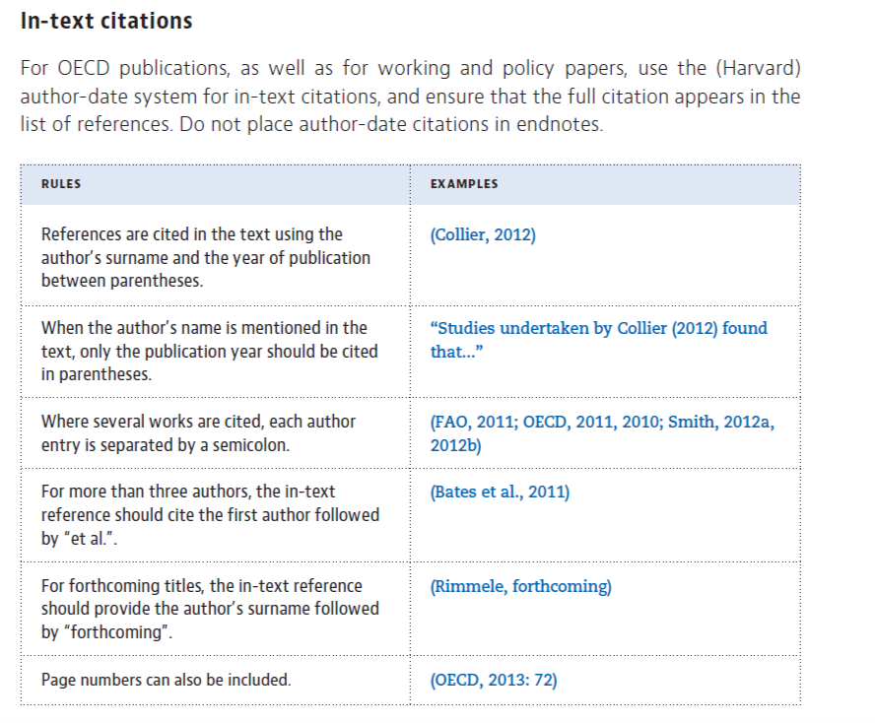

Units
The NEA has decided that the International System of Units (SI) should be used for all its documents. SI units are the most widely used and understood units for measurement in science in technology. Where common usage relies on a non-SI unit, it can be included in parentheses after the SI unit. Exceptions for this report are “MeV” and “GeV”.
Example:
Table A.1. Main Relevant Thermal Hydraulic Aspect Related to the Test 7 Part 2
Relevant Thermal Hydraulic aspects | Time (s) | Quantity
Triggering valve (F045) opening | Begins at 300 s, fully open at 326 s | -
Maximum level in the HXP | 442 s | 3.5 m
Maximum exchanged power | 444 s – 2500 s | 17 – 19 MW
OP discharge valve F031 opening | 1150 s | -
Triggering valve F045 closure | 3461 s | -
HXP level decreasing and loss of mass from the boil-off | 442 s - 5736 s | -

